**Pedagogies appropriate to English:**

The **Language in use model** is based on the Systemic functional linguistics theory of language (Halliday et al, 1975, 1985a, 1985b). The model describes how individuals make meaning of language and texts depending on their historical, social and cultural context. The Language in use model is based on the idea that language is a tool for communication and is used in different social contexts for specific purposes. It shows how language is a system of choice and these choices are used to construct meanings for a range of different purposes. The structure of the Australian Curriculum: English is framed by the Language in use model.

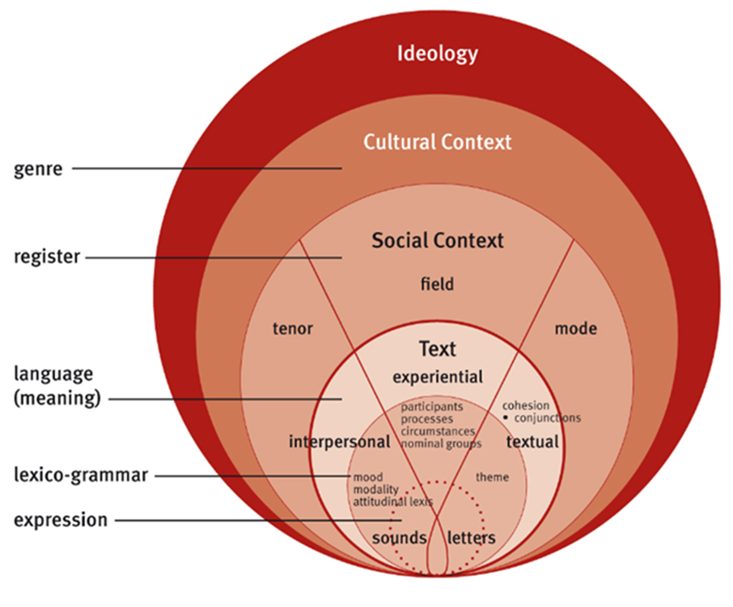

***Reading to Learn***, is used for the teaching of English and literacy within other subject areas. The methodology provides a unique approach to inclusion and differentiation within a whole-class setting, promoting support and extension for students in equal measure. When using the Reading to Learn methodology, students are explicitly taught how texts are structured and how language works across a range of texts. They systematically deconstruct small passages of text to study writing techniques of successful authors and use those techniques in their own writing. For more information please visit [Reading to Learn](http://www.readingtolearn.com.au/).

