**Pedagogies appropriate to HASS, STEM, The Arts and HPE:**

**Inquiry Based Learning** focuses on investigation and problem-solving and provides added benefits for our students in engagement and metacognition across the curriculum, as well as in those subjects where it is a natural component of the disciplinary approach. Teachers scaffold learning by starting with a range of scenarios, questions and problems for students to navigate. Inquiry-based learning prioritises problems that require critical and creative thinking so students can develop their abilities to ask questions, design investigations, interpret evidence, form explanations and arguments, and communicate findings.

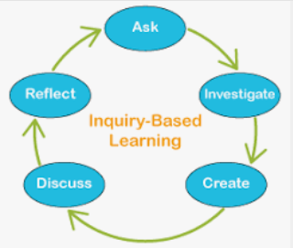

**Strengths-based approach** is a learner centred approach to teaching that recognises students have varying levels of access to personal skills, strengths, assets and community resources to maintain and promote their own and others’ wellbeing.  Health and Physical Education recognises that contextual factors impact peoples’ decisions and behaviours in relation to their health, safety, wellbeing and participation in physical activity.

