**Pedagogies appropriate to Mathematics:**

**Gradual Release of Responsibility**: Aligning to the school belief that all students can achieve high standards with the right time and support, teaching and learning in Mathematics is developed around the Gradual Release of Responsibility model. Teachers deliver a structured and sequenced approach to explicitly teaching new content. Gradual release of responsibility is not linear. Teachers move between modelling, guided and independent practice throughout lessons. Teachers make decisions based on student understanding and readiness, checking for understanding as they move students between modelled, guided, and independent practise.

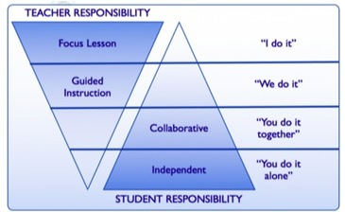

**Problem based learning** focusses on learning though problem solving using open-ended questions and challenging tasks that pose authentic problems. These tasks can be designed to allow students of all abilities to experience productive struggle and this struggle is facilitated and encouraged by the teacher. Teachers also provide students opportunities to think critically, persist with solving tasks, present their own creative ideas, and communicate mathematically with others.

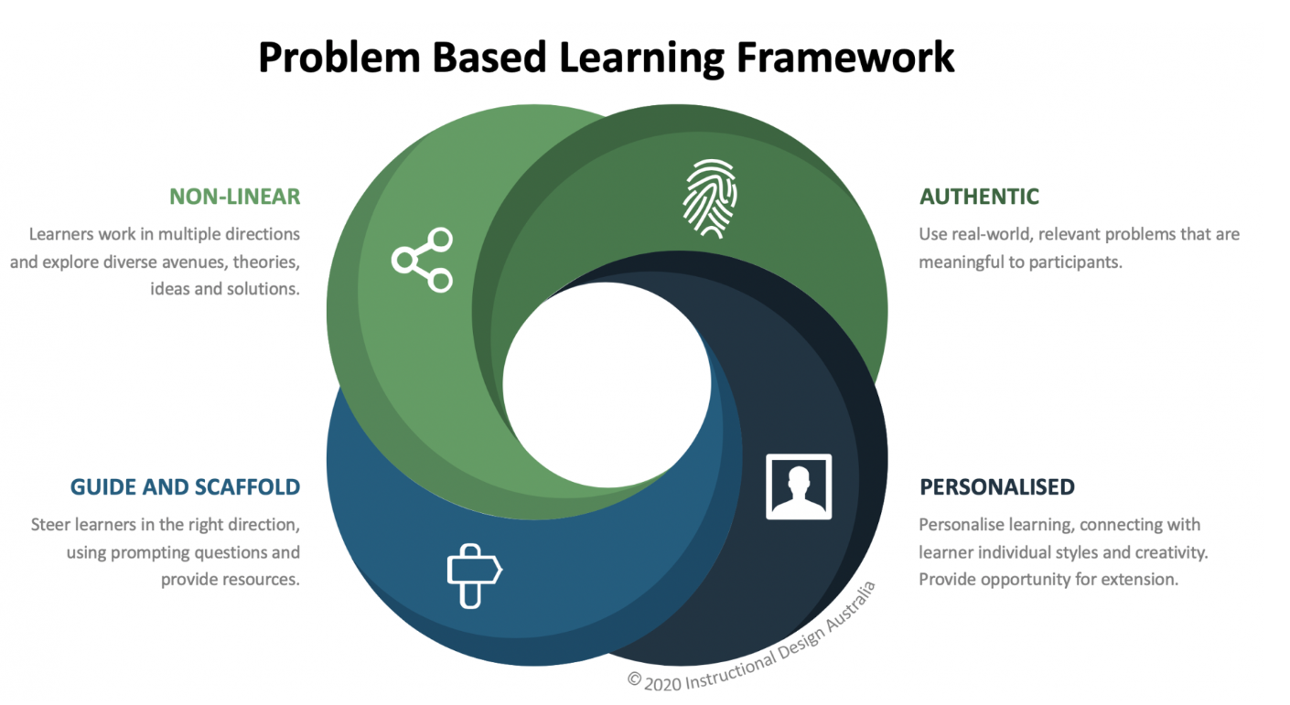

**Inquiry-based learning**, is a process using mathematical evidence to address complex problems that contain ambiguities (Makar 2012). Teachers use inquiry-based learning to prioritise problems that require critical and creative thinking so students can develop their ability to ask questions, design investigations, interpret evidence, form explanations and arguments, and communicate findings.

