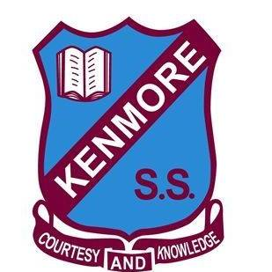

Kenmore State School - Transition to Prep 2025
Save-the-Date

Welcome to Kenmore State School. We are excited to welcome you to our school.
Please find below a few important dates for our Transition to Prep Program. You can contact our Office on 3327 2444 for more information or to book enrolment interviews and school tours.

Prep Information Session and School Tour
This information session will provide details of our approach to teaching and learning in the early years with an opportunity to meet the team. Families will also have the opportunity to visit the Prep classrooms.
- Friday 22 March 2024 9.30am (limited to 8 spaces – bookings essential by calling 3327 2444)
- Tuesday 07 May 2024 6.00pm
- Tuesday 23 July 2024 6.00pm
- Thursday 10 October 2024 6.00pm

Prep Enrolment Interviews
An opportunity to meet with a member of the Prep or Leadership Team to discuss your child’s transition to school. Please contact the office to make a booking.
- Saturday 24 August 2024 (8am-4pm)
- Saturday 12 October 2024 (8am-4pm)
- Or phone the office on 3327 2444 to make an alternative time

Prep Transition Program: ‘A Day in the Life of Prep’ Classroom Days
A series of three orientation sessions for enrolled students throughout Term 4, providing children with ‘A Day in the Life of Prep’ experience. A series of workshops for parents will also be offered at this time.
- Thursday 31 October 2024 8.30 - 10.30am
- Thursday 06 November 2024 8.30 - 10.30am
- Thursday 14 November 2024 8.30 - 10.30am

First Day of School
Students start their exciting journey of learning and independence.
- Tuesday 28 January 2025

Parent-Teacher Information Night
This session outlines the teaching and learning focus, daily routines, and supporting your child at school.
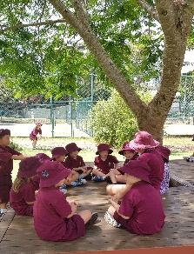
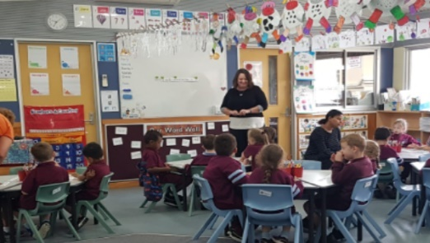
- Term 1 2025

